Dear Friend of EcoWorks,

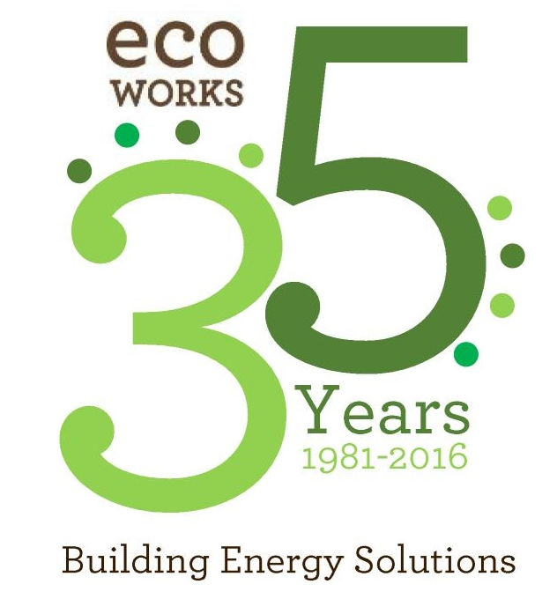
EcoWorks is proud to announce the kickoff of our 8th Annual Breakfast! We are also celebrating our 35th anniversary. The event will be November 4th, 2016 at the Detroit Yacht Club in Detroit. The program is 2 hours in length, from 8am to 10am, and Breakfast has become a mainstay in the sustainability community and provides a unique opportunity for exposure to an audience of sustainability leaders in the region.
Our Annual Breakfast has brought you thought provoking speakers for the last 7 years from across the nation. This year, we are honored to host Winona LaDuke as our keynote speaker. Winona LaDuke (Ojibwe) is an internationally renowned Native American Indian activist and advocate for environmental, women's, and children's rights. She is the founder and campaign director of the White Earth Land Recovery Project, a reservation-based land acquisition, environmental advocacy, and cultural organization. She is also founder and co-chair of the Indigenous Women's Network.
Another much anticipated part of the morning’s celebration is the presentation of four Sustainable Community Champion Awards. The awards recognize individuals and organizations in the Southeast Michigan region that provide leadership in energy efficiency, sustainable building practices, community development and related fields. We will celebrate local success stories and honor true leadership.

2015 Awardees

- Malik Yakini, Executive Director, The Detroit Black Community Food Security Network
- Soulardarity, Neighborhood cooperative in Highland Park that installed 200 solar streetlights with the help of local residents.
- Jim Newman, Managing Partner Newman Consulting Group Network
- John Viera, Ford Motor Company‘s Director of Sustainable Business Strategies

As with all of our Annual Breakfasts, you will have the opportunity to network with over 150 leading professionals from industry, government, non-profits, financial firms, and the community. As an important member of our community and an organization that values the EcoWorks mission, now is the time for you to expand your brand recognition as a supporter of sustainable solutions. Several 8th Annual Breakfast sponsorship opportunities, detailed below, are available to meet your needs and budget. The earlier your organization becomes a sponsor, the more opportunities you have to promote your organization to hundreds of EcoWorks supporters and partners. All sponsorships are tax deductible.

We look forward to working with you to further the mission of EcoWorks and honor Sustainable Community Champions at our 35th Anniversary Celebration and 8th Annual Breakfast. To commit your support for this event and become an official sponsor, please contact Alicia Miller at 313-418-8303 with any questions or send an e-mail to amiller@ecoworksdetroit.org.

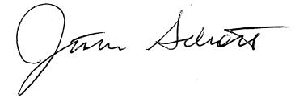
Kind Regards,

Justin Schott, Executive Director
innovative education, job training, consulting, social business, and advocacy

Sponsorship Levels

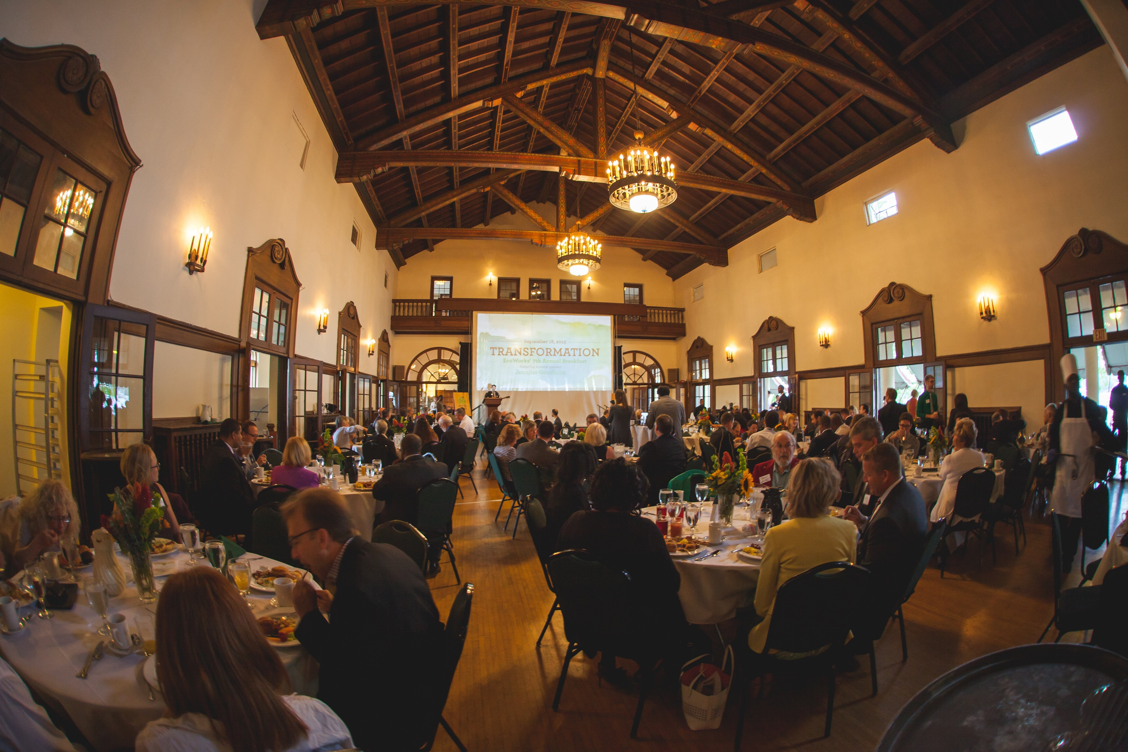
Anniversary Sponsor ($35,000)
- Yearlong recognition on EcoWorks website, marketing materials and events
- Selection of additional lead sponsorship for EcoWorks program or event
- One table (seats 8) to the 8th Annual Breakfast
- Your logo prominently displayed on printed materials and EcoWorks website
- Prominent signage at event with your logo displayed
- Full page ad in the event program book
- Opportunity to address the audience
- Mention on all radio promos as Anniversary Sponsor
- Company logo with live link on website to the URL of your choice for entire year
- Company logo and recognition on 10 e-blasts sent out to over 4000 people
- Table space at event for distribution of corporate literature or products
- Acknowledgement of sponsorship in press release
- Recognition at the event
- On-going recognition on social media
- Category exclusivity
- Event will be branded as presented by EcoWorks and “your company”

Presenting Sponsor ($13,500)
- One table (seats 8) to the 8th Annual Breakfast
- Your logo prominently displayed on all printed materials and EcoWorks website
- Prominent signage at event with your logo displayed
- Full page ad in the event program book
- Opportunity to address the audience
- Mention on all radio promos as Presenting Sponsor
- Company logo with live link on website to the URL of your choice
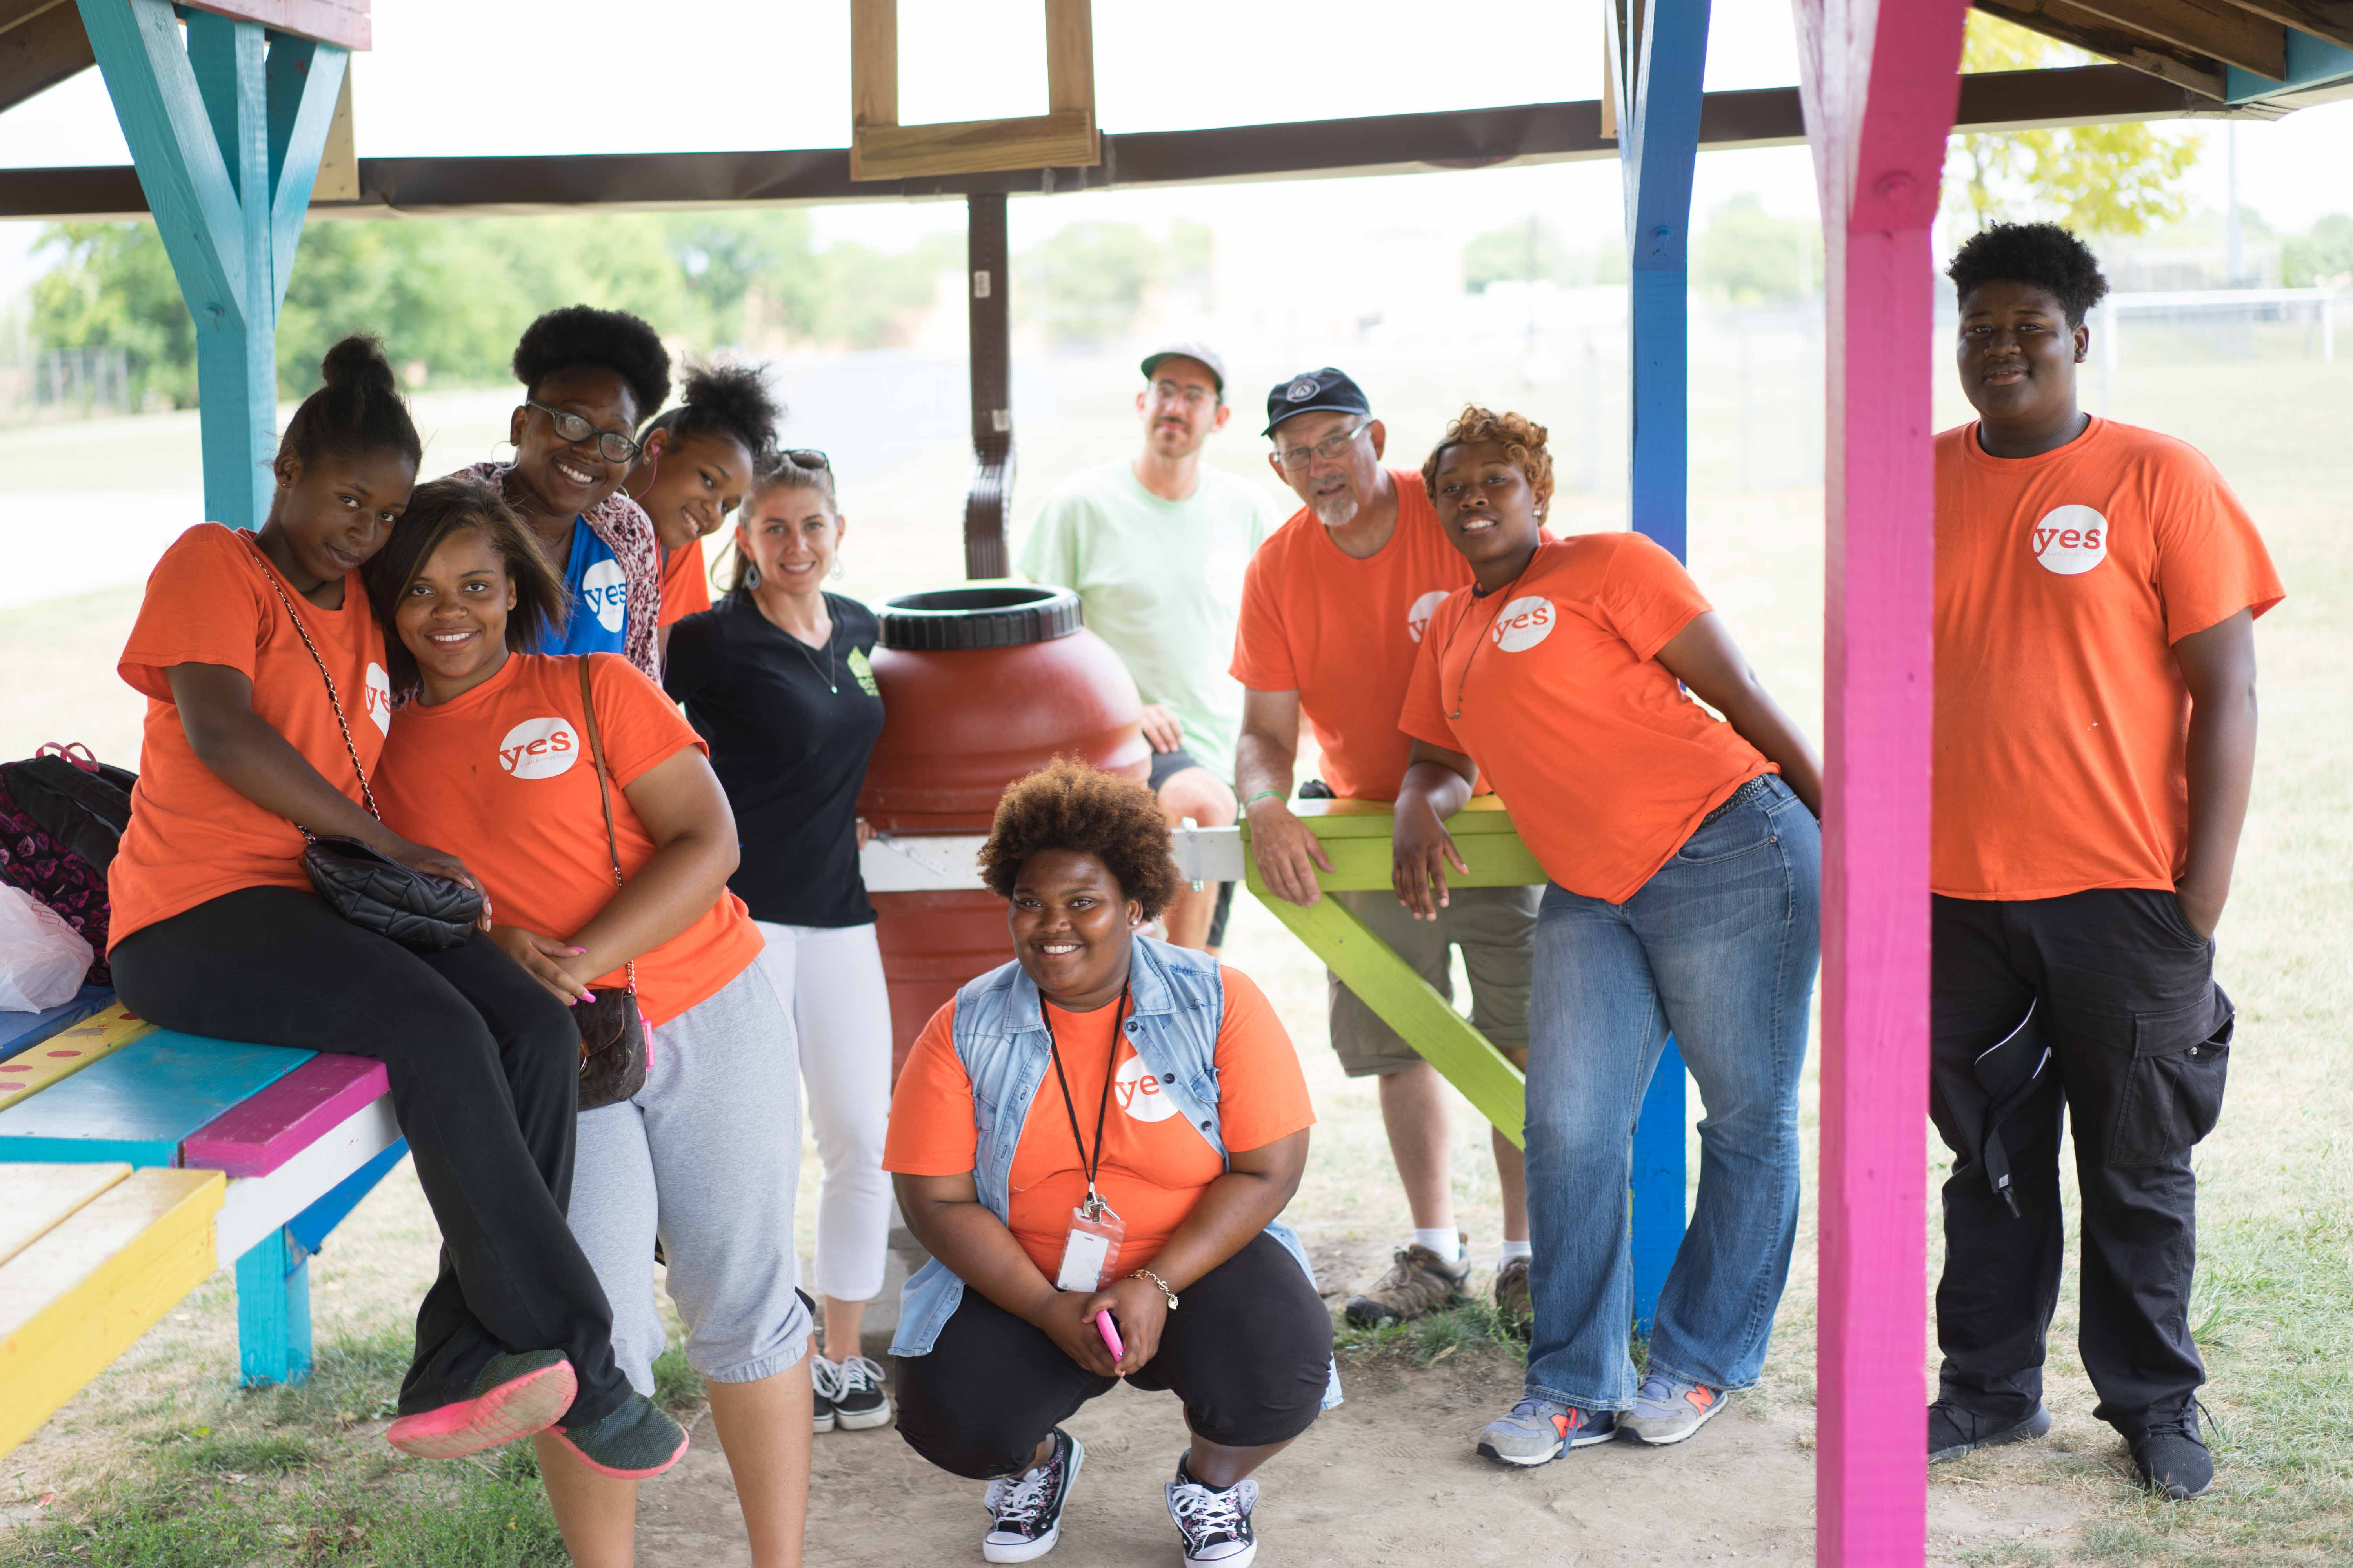
- Company logo on 4 e-blasts sent out to over 4000 people
- Table space at event for distribution of corporate literature or products
- Acknowledgement of sponsorship in press release
- Recognition at the event
- Recognition on social media
- Category exclusivity
- Event will be branded as presented by EcoWorks and “your company”

Sponsorship Levels
(Continued)
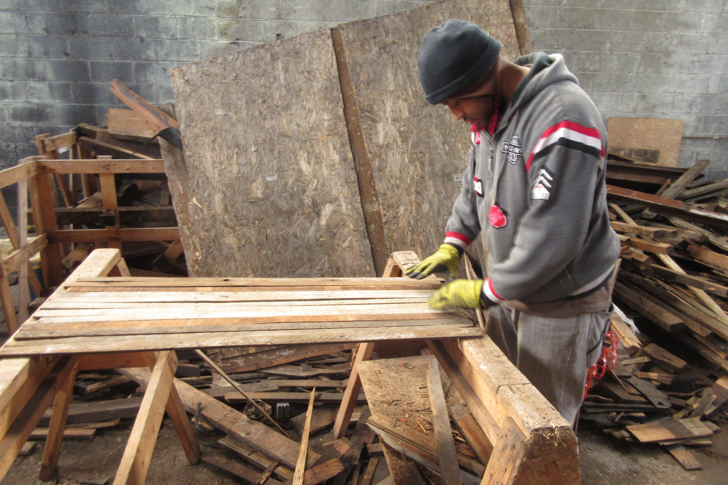
Sustaining Sponsor ($5,000)
- One table (seats 8) to the 8th Annual Breakfast
- Your logo prominently displayed on all printed materials and EcoWorks website
- Prominent signage at event with your logo displayed
- ½ page ad in the event program book
- Opportunity to address the audience
- Company logo with live link on website to the URL of your choice
- Company logo on 4 e-blasts sent out to over 4000 people
- Table space at event for distribution of corporate literature or products
- Acknowledgement of sponsorship in press release
- Recognition at the event
- Recognition on social media

Energy Sponsor ($3,500)
- Six tickets to the 8th Annual Breakfast
- Your logo prominently displayed on all printed materials and EcoWorks website
- Company logo in program book
- Company logo with live link on website to the URL of your choice
- Company logo on 4 e-blasts sent out to over 4000 people
- Table space at event for distribution of corporate literature or products
- Acknowledgement of sponsorship in press release
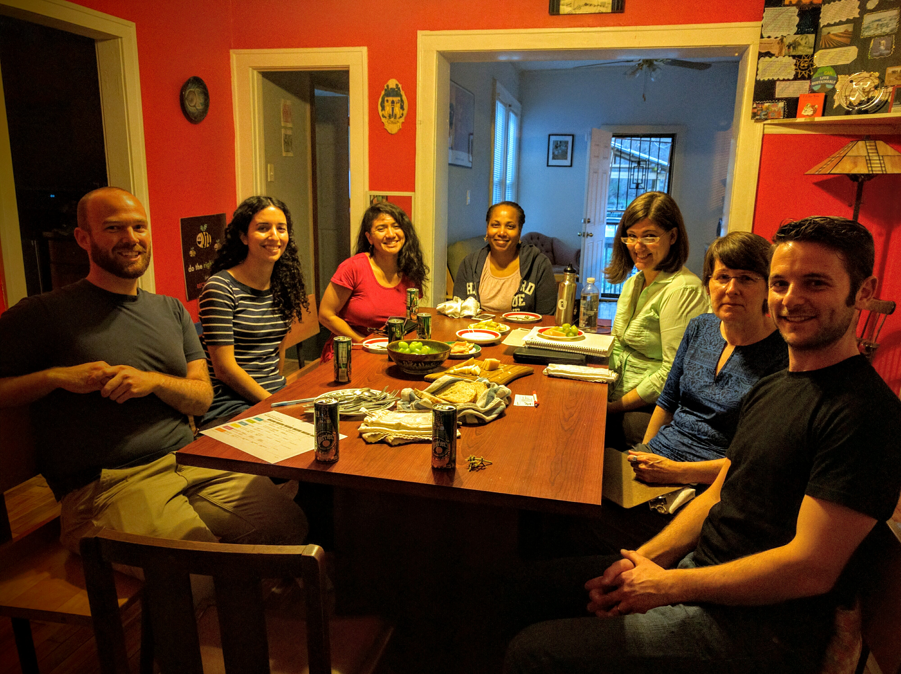
- Recognition at the event

Green Sponsor ($1,350)
- Four tickets to the 8th Annual Breakfast
- Table space at event for distribution of corporate literature or products
- Company logo with live link on website to the URL of your choice
- Recognition at the event
- Company name in program book

Table Sponsor ($750)
- 8 tickets to the 8th Annual Breakfast
- Company name in program book

*Your sponsorship is tax deductible*

EcoWorks Annual Breakfast
2016 Sponsorship Form

Please complete the following form, along with your payment and send to:
EcoWorks
Attn: Annual Breakfast Sponsorship
4835 Michigan Ave Detroit, MI 48210
E-mail to: amiller@ecoworksdetroit.org
Make check payable to “EcoWorks”

Company Name: _______________________________________________________

Address: _______________________________________________________

_______________________________________________________

Phone Number: _______________________________________________________

Representative Name: _______________________________________________________

Representative Email Address: __________________________________________________

Select your sponsorship level:
- Anniversary Sponsor ($35,000)
- Presenting Sponsor ($13,500)
- Sustaining Sponsor ($5,000)
- Energy Sponsor ($3,500)
- Green Sponsor ($1,350)
- Table Sponsor ($750)

Representative Signature:

_____________________________________________________

Date: ______________________

THANK YOU FOR HELPING US CELEBRATE 35 YEARS!

